## SoftTerest

This task has automated tests, included in the resources. To run the tests, install dependencies with **npm install**, then run in two **separate** terminals the following commands:

**npm run start**

**npm run test**

There is **no need to submit** this task for manual peer-assessment.

You are assigned to implement a **Single** **Web Application** (SPA), such that it passes all provided tests. The app keeps **users** and **ideas**. **Guests** should be able to **register** and **login**. Users should be able to view **all ideas**, **create** **ideas**, see **details** about an **idea** and **logout**. Users should also be able to **delete** the ideas **they have created**.

### Navigation Bar

Navigation links should correctly change the current page (view).

* Clicking on the links in the **NavBar** should display the view behind the link (views are represented as sections in the HTML code).
* Your application may **hide**/**show elements** by CSS (display: none) or **delete**/**reattach** from and to the DOM all unneeded elements, or just display the views it needs to display.
* The Logged-in user navbar should contain the following elements: Icon (icon.jpg) which is a **link** to the Home page, [Dashboard], [Create], [Logout].
  + The Icon should be a link that navigates to the **currently logged in user’s** **profile**.
* The guest users navbar should contain the following elements: : Icon (icon.jpg) which is a **link** to the Home page, [Dashboard], [Register] and [Login].



### Home Page

The initial page (view) should display the **navigation bar** ("Home" (icon), "Dashboard", "Register"and "Login") + Home Page + Footer.

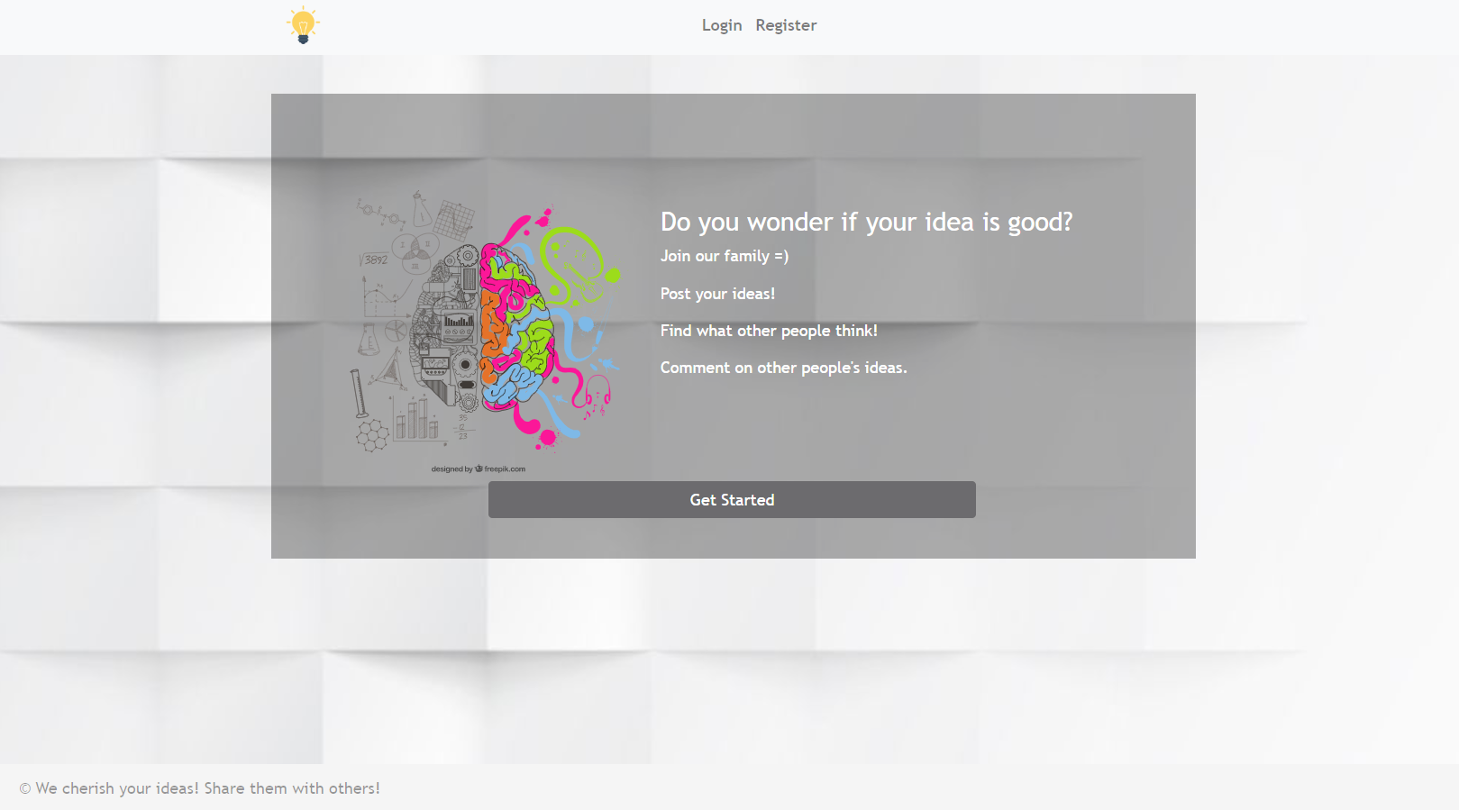

### Register User

By given **email** and **password,** the app should register a new user in the system.

* The following validations should be made:
  + The **email** should be **at least 3 characters** long, have **digits** and **special characters**
  + The **password** should be **at least 3 characters** long
  + The **repeat password** should be **equal to the password**
* After a **successful registration** the app should **redirect** to the **home page with the right navbar**.
* In case of **error** (eg. invalid email/password), the user should be able to **try** to register again.
* Keep the user session data in the browser's **local storage**.
* **POST** request **- http://localhost:3030/users/register**

Register once and create/Like awesome ideas!

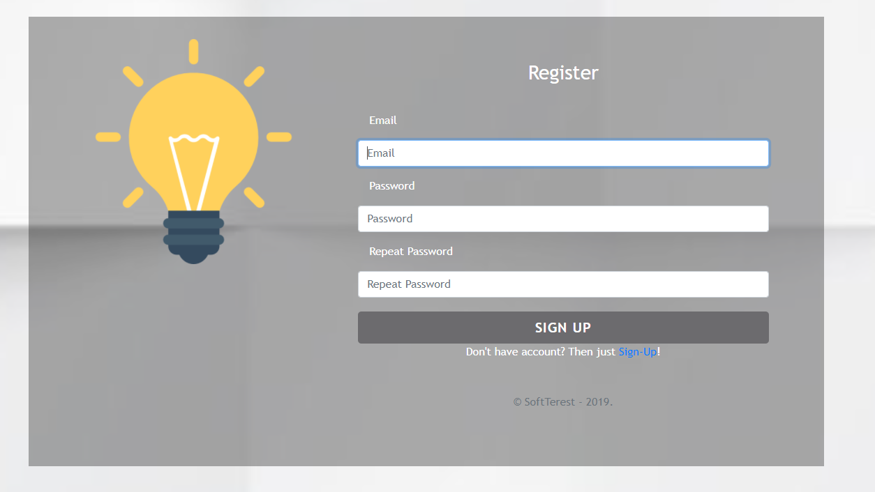

### Login User

By given **email** and **password,** the app should login an existing user.

* After a **successful login** and the user home screen should be displayed.
* In case of **error**, the user should be able to fill in the login form again.
* Keep the user session data in the browser's **local storage**.
* Clear **all** input fields after a **successful** login.
* **POST** request - **http://localhost:3030/users/login**

You are one step away from awesome ideas!

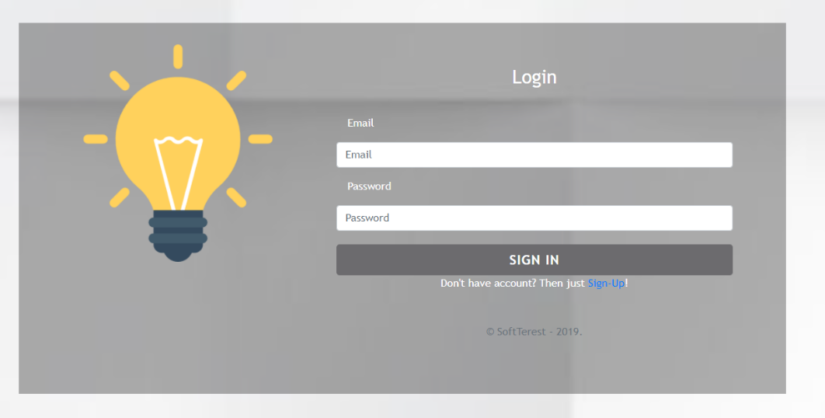

### Logout

Successfully logged in users should be able to **logout** from the app.

* After a **successful** logot the **anonymous screen** should be shown
* The **"logout" REST service** at the back-end **must** be called at logout
* All local information in the browser (**user session data**) about the current user should be deleted
* **GET** request - **http://localhost:3030/users/logout**

### Dashboard

All users should be able to see the Dashboard. They should be able to see all created ideas.

**GET** request - **http://localhost:3030/data/ideas?select=_id%2Ctitle%2Cimg&sortBy=_createdOn%20desc**

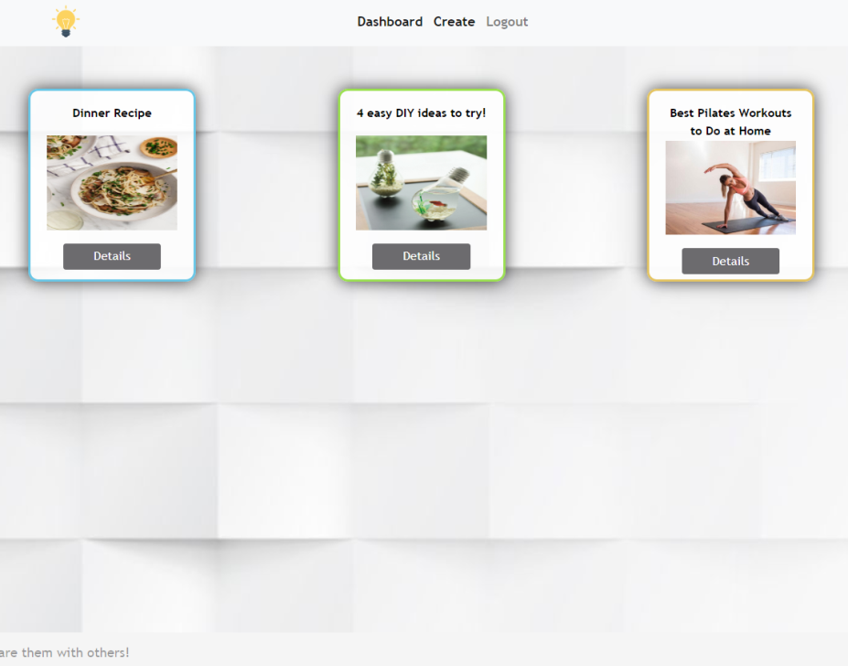

If there are **NO** such ideas, the following view should be displayed:



### Create

Logged-in users should be able to **Create** ideas.

Clicking the [Create] **link** in the **NavBar** should **display** the Create page.

* The form should contain the following validations:
  + The **title** should be **at least 6 characters** long.
  + The **description** should be **at least 10 characters** long.
  + The **image** should be **at least 5 characters** long.
  + After a **successful** idea creation the Dashboardshould be shown.
* The inputs fields in the form **should be cleared.**
* **POST** request - **http://localhost:3030/data/ideas**

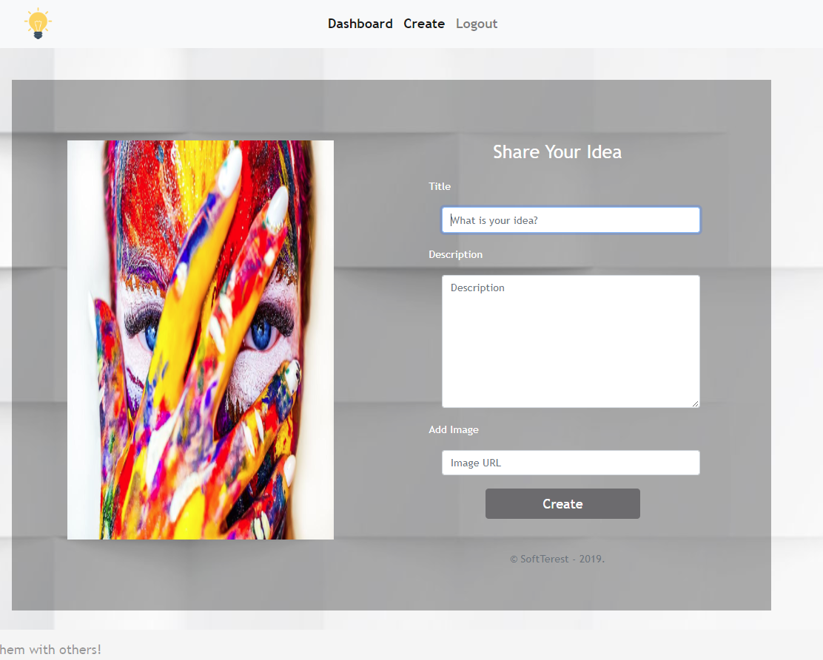

### Idea Details

Logged-in users should be able to **view details** aboutideas.

Clicking the [Details] **link** in of a **particular idea** should **display** the Idea Details page.

* If the currently logged-in user is the organizer of the idea, [Delete] **button** should be set to **visible.**

**GET** request - **http://localhost:3030/data/ideas/:id –** for idea details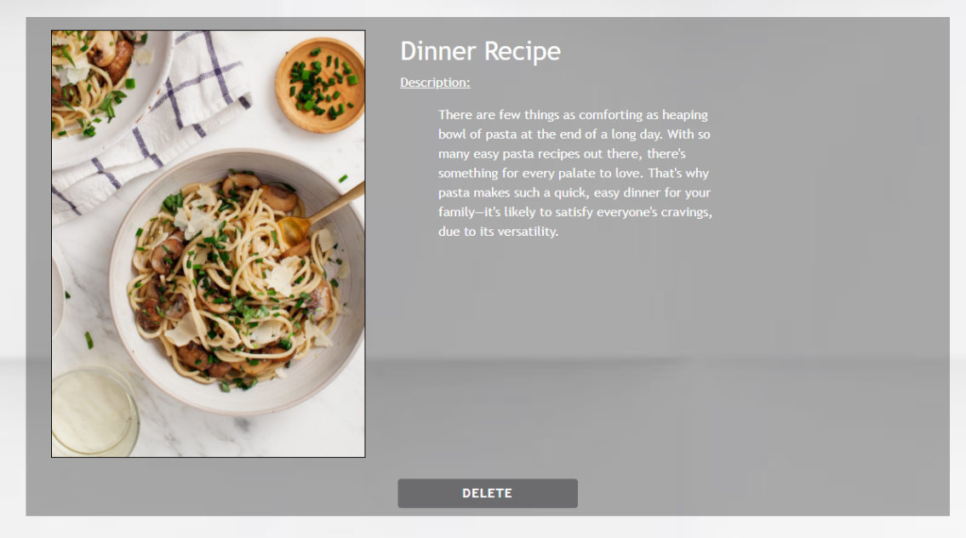

### Delete Idea

Logged-in users should be able to **delete their** ideas.

Clicking the [Delete] **link** of an **idea** (on the Idea Details page) should **delete** the **idea**.

* After **successful** **idea delete** the Dashboard should be **shown**
* **DELETE** request - **http://localhost:3030/data/ideas/:id**